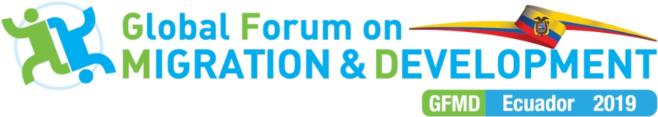

Non-Paper in Preparation of the Informal Consultation with the GFMD Friends of the Forum on the Role of the GFMD in the International Migration Review Forum (IMRF)
4 April 2019, Geneva

As outlined in the letter to the Friends of the Forum, the Ecuadorian Chair of the 2019 GFMD proposes to hold an informal consultation with the Friends of the Forum of the GFMD on the role the Forum may take in the International Migration Review Forum. The outcome of this consultation will be used to articulate a letter by the Chair to the co-facilitators establishing broad parameters for the relationship.
The Chair proposes that participants consider a set of framing questions presented below in anticipation of the consultation. These questions are accompanied by points of potential consensus that participants may find useful when preparing their positions.

Framing Questions:
- In broad terms, how can GFMD as a voluntary, state-led, inclusive process fulfil the functions foreseen by the GCM; particularly to provide platforms to exchange experiences on the implementation of the Global Compact, share good practices on policies and cooperation, promote innovative approaches, and foster multi-stakeholder partnerships around specific policy issues and to provide a space for annual informal exchange on the implementation of the Global Compact, and to report the findings, best practices and innovative approaches to the International Migration Review Forum??

Points of potential consensus:

- Supporting pillars of the GCM – including the IMRF – must retain their non-binding character and be open to engagement with and participation by all Member States.

- While contributing positively and constructively to the GCM, the mandate and value of GFMD must not be reduced to the roles attributed to it by the GCM but must continue to be focused on facilitating dialogue on issues that span the whole spectrum of migration and development, including emerging and potentially contentious challenges outside the scope of the GCM. We need to acknowledge that many elements mentioned in the GCM predate the compact or would have been created anyway.

- GFMD needs to focus on its unique features to remain as the indispensable partner in assisting Member States to discuss the links between migration and development at the global level.

- How can GFMD play a role in the implementation of GCM?

Points of potential consensus:

- Implementation of GCM commitments is the prerogative of Member States; Member States may be assisted, supported and advised in that role by global and regional processes, members of the Migration Network, and other relevant institutions.

- As per the text of the GCM, GFMD can provide a platform to exchange experiences on the implementation of the Global Compact, share good practices on policies and cooperation, promote innovative approaches, and foster multi-stakeholder partnerships around specific policy issues; and by doing so, empower Member States to implement GCM objectives.

- In keeping with the principle of not reinventing the wheel and making use of existing mechanisms, GFMD can improve its capacity to provide this space by expanding and developing the Platform for Partnerships – in accordance with paragraph 43 c) of the GCM – to compile and curate information on implementation provided by Member States; and disseminate this information in a way that is beneficial to all stakeholders.

- As the largest and most inclusive global process on migration and development, the GFMD could offer dedicated segments of the annual GFMD Summit as a space for stocktaking and cooperation that have been forged in the framework of GCM implementation.

- The GFMD could ensure that the government-led Roundtables (RT), which are a key feature of the GFMD Summit Meeting, acknowledge GCM-related objectives. Like in 2017, dedicated GCM rapporteurs may be assigned to take stock of policy suggestions and options for practical action that have been brought up during the actual RT discussions.

- How can IMRF best incorporate inputs from GFMD?

Points of potential consensus:

- As a state-led, voluntary review, Member States can choose to submit their own reviews directly to the IMRF, through Regional Consultative Processes (RCP) and the Inter-Regional Dialogue of RCPs, as well as through GFMD’s Platform for Partnerships.

- GFMD’s Platform for Partnerships can develop capacity to capture voluntary reporting by Member States to the aforementioned processes, as well as draft and document its own reports – subject to the approval of Member States – that highlight best practices, key developments and general trends, aligned with the objectives of the Global Compact, for submission to the IMRF.

- GFMD may seek synergies with regional consultative process – by, for example, working with IOM to align Global RCP meetings (GRCPs) with GFMD Summits – to enable RCPs and ISCMs to take advantage of GFMD as a platform for annual global reporting on regional initiatives.

- How should the relationship between GFMD and the Migration Network be framed?

Points of potential consensus:

- The role of the UN system is crucial in empowering Member States to implement, follow up and to report on their progress. The Migration Network can play a key role through facilitating the transfer of technical assistance to Member States, upon their request.

- The GFMD Platform for Partnerships, already cited in the GCM as a potential building block of the UN capacity-building mechanism, could be improved by a) introducing “quality control” criteria for good practices and, potentially offering States and others who have submitted practices the opportunity to access evaluation services; and b) developing more interactive tools for online knowledge sharing, such as online communities of practice, tutorials and online learning courses.

